Web Development

**How internet works:**

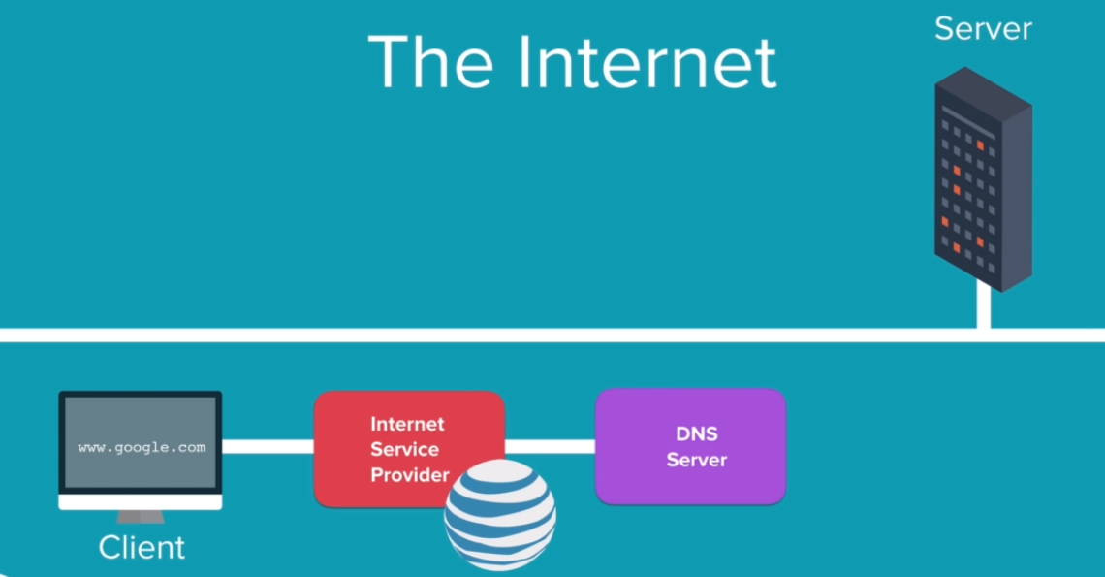

Request is sent to ISP, then it is sent to DNS server to get the IP address, and then using that IP address, we locate the server to access the website.

**Documentation for Web dev**

* MDN: <https://developer.mozilla.org/en-US/docs/Learn/HTML>
* W3 school: https://www.w3schools.com/html/
* Dev docs: <https://devdocs.io/>

**HTML Tags**

* Non-closing tags:
  + <html> Defines an HTML document
  + <head> Contains metadata/information for the document
  + <title> Defines a title for the document
  + <body> Defines the document's body
  + <h1> to <h6> Defines HTML headings
  + <p> Defines a paragraph
  + <div> Defines a section in a document
  + <a> Defines a hyperlink
  + <i> Defines Italic text
  + <em> Defines Italic text, emphasized i.e. works on all language.
  + <b> Defines bold text
  + <strong> Defines important text, Works on all language.
  + <ul> Defines an unordered list
  + <ol> Defines an ordered list
  + <li> Defines a list item
* Self-closing tag:
  + <br> Inserts a single line break
  + <hr> Defines a thematic change in the content
  + <img> Defines an image